Android Mobile Applcation



Patrick Ware

2021001676

Contents

1. Introduction 3

2. Application features 3

2.1 Multi-language support 3

2.2 Device Support 3

3. Application Design 4

3.1 Design Inspiration (Original Console Application) 4

3.2 Wireframe Application Sketches 5

3.2.1 Home Screen 5

3.2.2 Edit Quiz Menu 5

3.2.3 Quiz topic selection menu 6

3.2.4 Quiz Activity 7

3.2.5 Show All Questions View 8

3.3 Material design 8

4. Database 10

5. Implementation 10

5.1 Main Activity 11

5.2 Quiz ME Activity 12

5.3 Edit Quiz Menu Activity 13

5.4 Question List activity 14

5.5 Quiz Activity 14

5.5.1 Question Display 15

5.5.2 Incorrect Answer Prompt 15

5.5.3 Correct Answer Response 16

5.5.4Quiz Result Pop-up 16

5.6 String Resources 17

6 Testing 18

6.1 Samsung Galaxy A13 (Portrait) 18

6.1.1 Quiz Activity (with Home screen and Topic Selection)f 18

6.1.2 Edit Quiz Menu Activity 19

6.1.3 Show all Questions recycler view activity 20

6.2 Samsung Galaxy A13 (Landscape) 21

6.2.1Quiz Activity (with Home screen and Topic Selection) 21

6.2.2 Edit Quiz Menu activity 22

6.2.3 Show all Questions recycler view activity 23

6.3 Nexus 10 (Portrait) 23

6.3.1 Home Screen 23

6.3.2 Quiz Activity (ith Topic Choice Menu) 24

6.3.3 Edit Quiz Menu Activity 25

6.3.4 Show all Questions recycler view activity 25

6.4 Nexus 10 (Landscape) 26

6.4.1 Home Screen 26

6.4.2 Quiz Activity (With Topic Choice Menu) 26

6.4.3 Edit Quiz Menu Activity 26

6.4.4 Show all Questions recycler view activity 27

6.5 Changes made after initial testing. 28

7 Conclusion 29

8 References 30

# Introduction

Ignatius Will be created as an android application based on the C# Console program of the same name that was created during the summer break at the end of last year.

The purpose of Ignatius will be used as a study aid for end of term examinations which commonly employ a combination of short answer and multiple-choice questions.

After creating the original program, the next logical step was to upgrade to a platform that offers GUI rather just a terminal and creating the application for mobile means that I can use it anywhere.

# Application features

As Ignatius is based on the console of the same name it is intended that the following features will be available:

* The options to add and remove questions in the quiz bank.
* The option to be quizzed on all questions on your choice of subject.

## 2.1 multi-language support

The application will have two languages available for users which will be English and German, the multi-language translation will include the application interface only, the quiz questions and topics will not be translated and will be limited to the language in which the user added them.

## 2.2 Device Support

Ignatius will need to function on a wide range of android devices including phones and tablets with varying screen size.

The application will Target API 26 (Android 8.0 Oreo) As this will mean that Ignatius will be supported by almost 91 percent of devices running the android Operating System.   
During the development and testing Ignatius the following virtual and physical devices will be utilized:

|  |  |  |  |  |
| --- | --- | --- | --- | --- |
| Device Model | Device Type | Screen Size | Android Version | Physical OR Virtual |
| Samsung Galaxy A13 | Phone | 6.6” | Android 12  (Snow Cone API 31) | Physical |
| Nexus 10 | Tablet | 10.05” | Android 12 (Snow Cone API 31) | Virtual |
| Pixel 6 | Phone | 6.4” | Android 8 (Oreo API 26) | Virtual |

# Application Design

In regards the design of the applications user interface the intention is for it to laid out in a similar way to the original console application with a banner/app bar image and simple navigation menu to direct users to the desired activity.

## 3.1 Design Inspiration (Original Console Application)

The original console application requires users to enter the number of the option they want. Screenshots of the original applications menus can be found below.

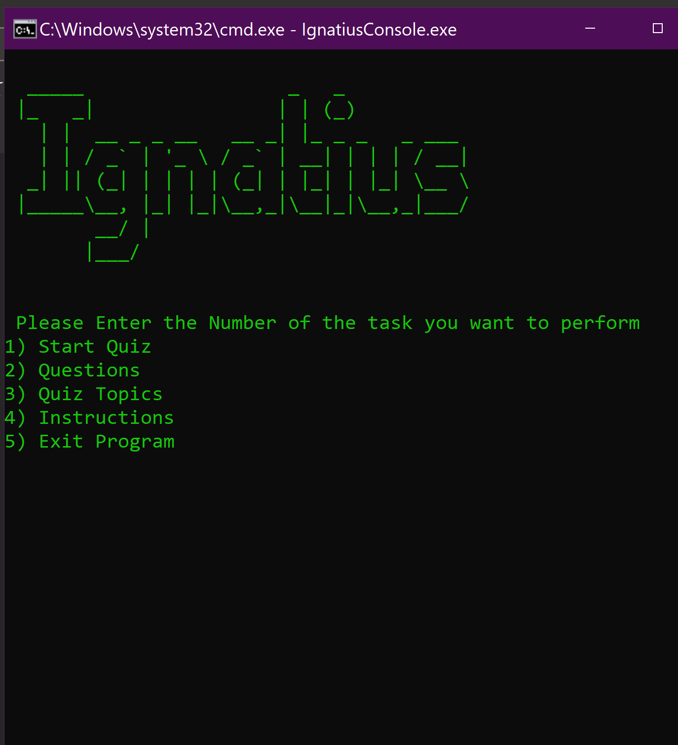 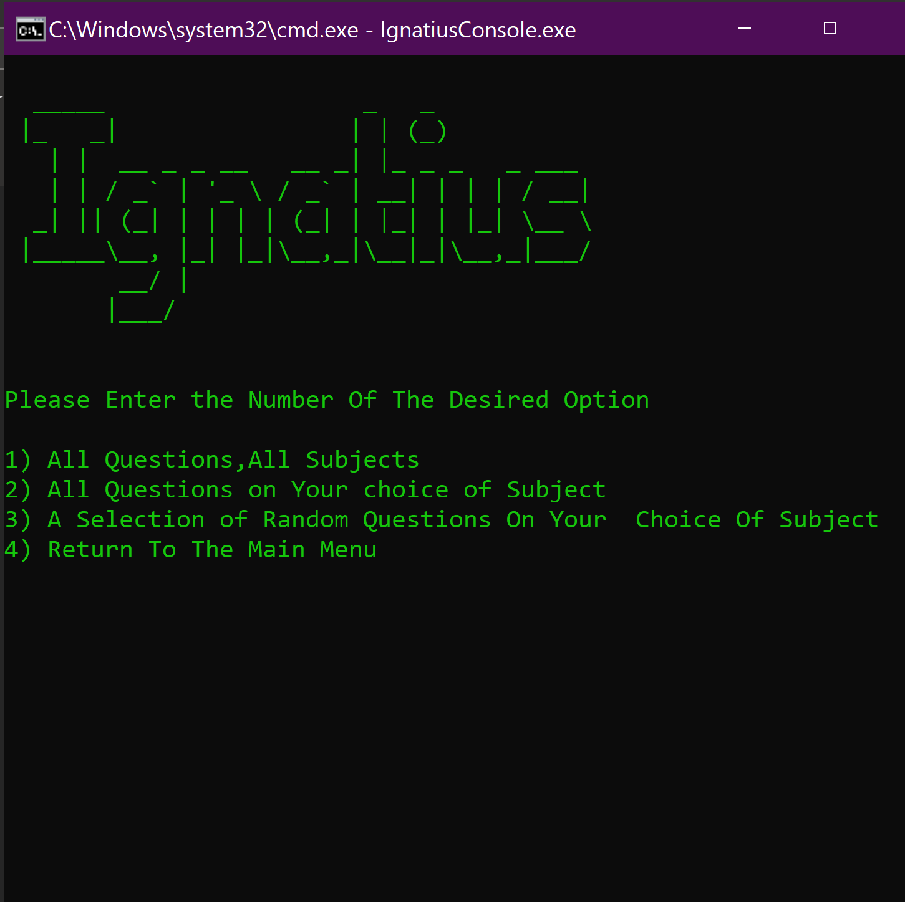 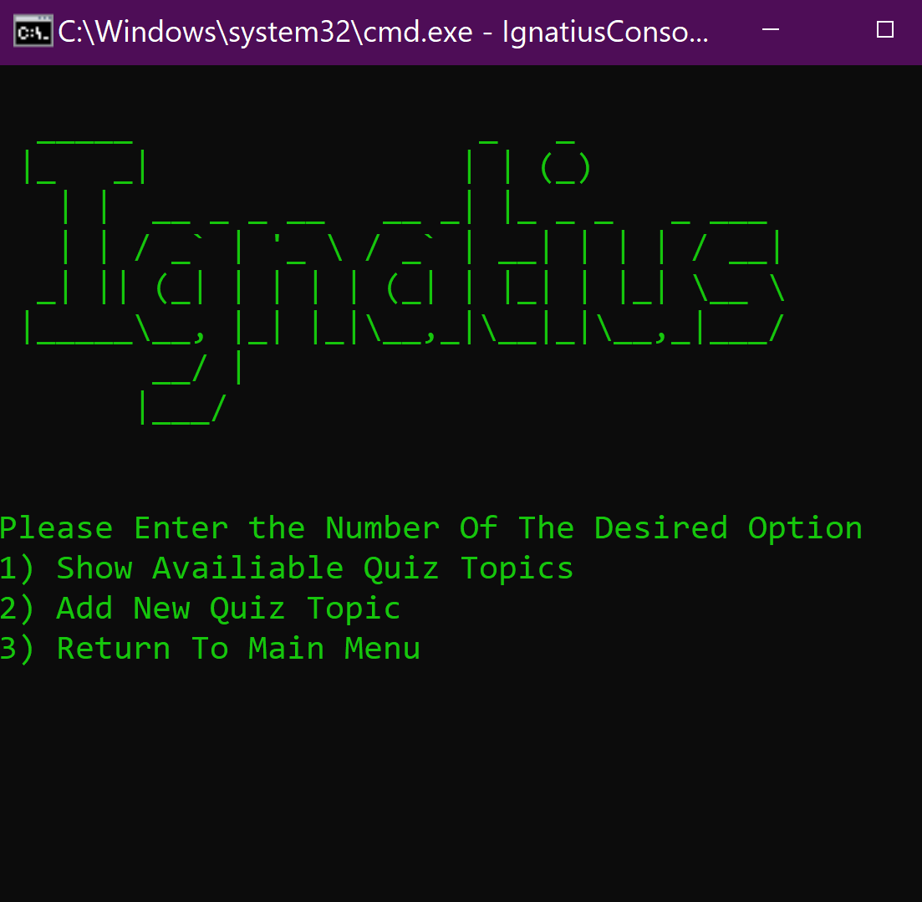 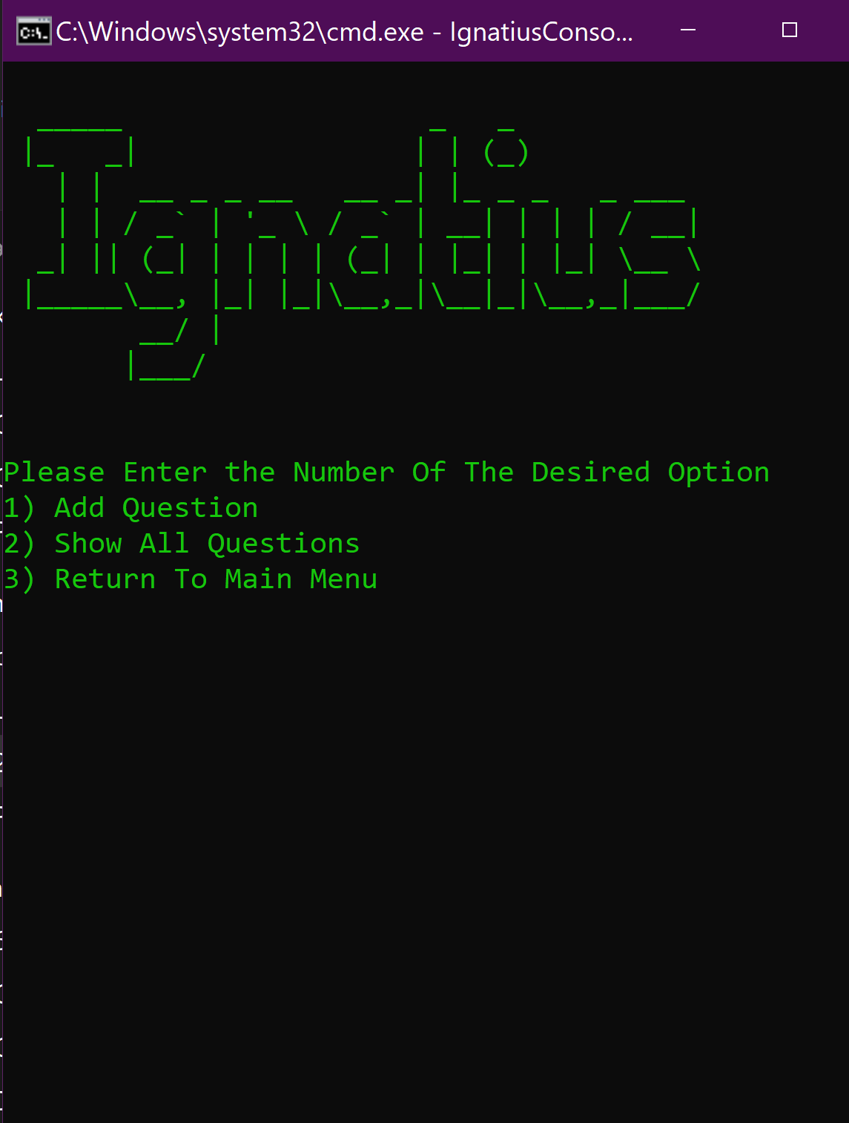

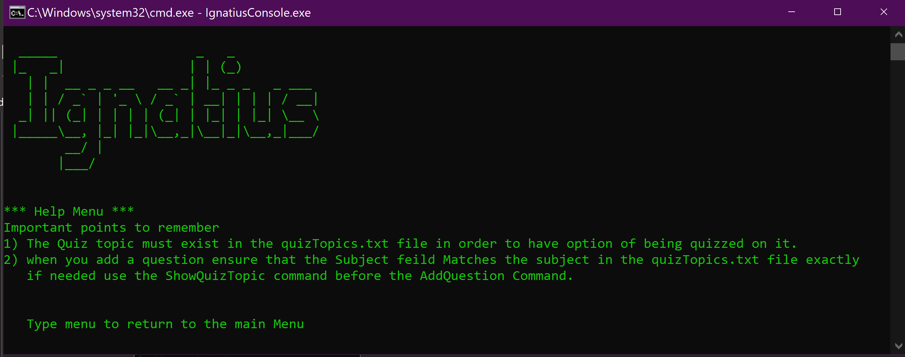

## Wireframe Application Sketches

The basic Wireframe design for how the application will look on a Phone can be seen below.

### Home Screen

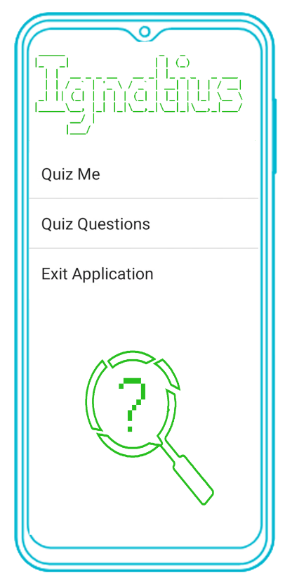

### Edit Quiz Menu

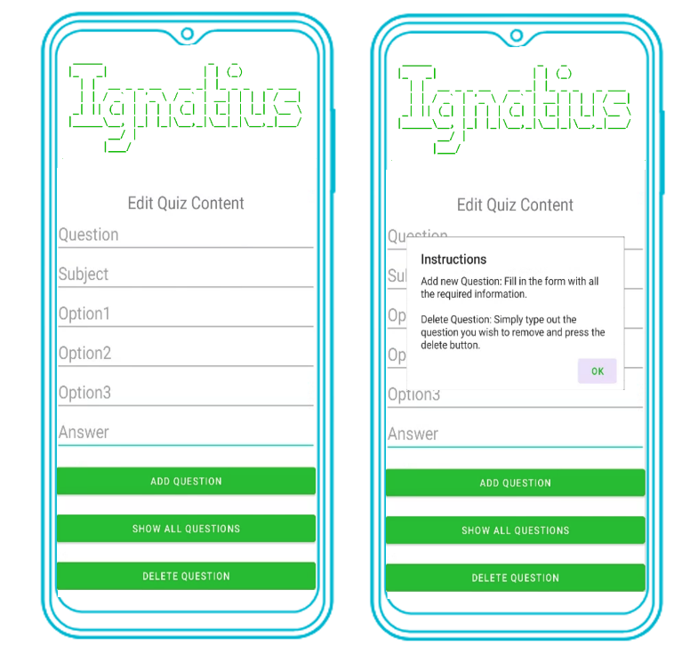Upon opening this activity users will be shown a prompt on how to edit the quiz content.

This message will inform them on how to both add new questions to quiz bank and remove old ones.

### Quiz topic selection menu



### Quiz Activity

the quiz application will be set to show a question and three possible answers to the user and then inform them whether they got the right answer.



### 3.2.5 Show All Questions View

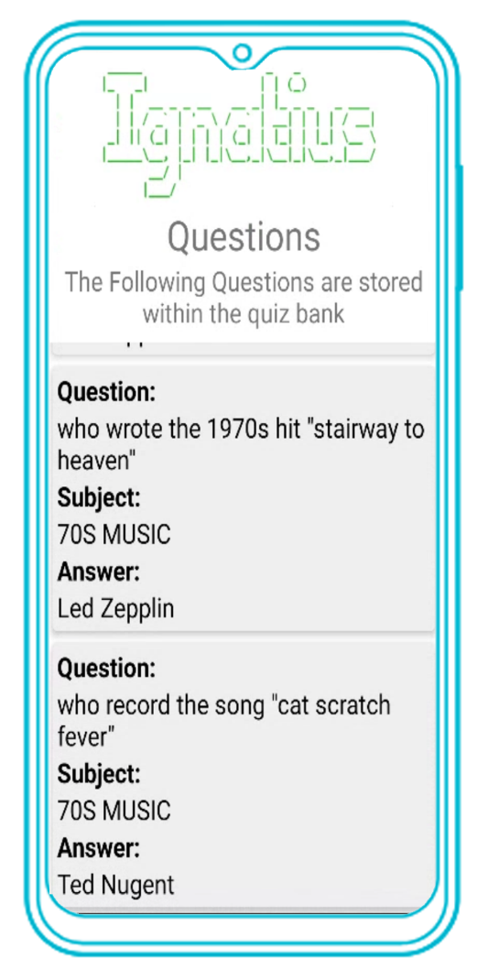all the questions currently stored in the quiz bank will be shown in a recycler to the user when this option is selected from the edit quiz menu.  
  
To avoid showing too much information only the question, the subject and the correct answer will be shown to the user.

The use of questions about music in the 70s are for demonstration purposes only.

## Material design

Ignatius Adheres to the material design principles by incorporating the following features in its design:

* A Responsive Layout on devices with different screen sizes and screen orientations including smartphones and tablets.
* Contextual Feedback: The applications provide meaningful feedback and informing them of their applications and response given by the application actions and the system's response. example of this within the application include:

* if an incorrect answer is selected during a quiz, an alert box appears to inform them of their selection and the correct answer and providing with a valuable learning opportunity, additionally snack bar notification will inform users when a correct is selected as well as when questions are added or removed from thew quiz bank or when they question they want to add already or exists or a question they want to erase is not actually stored in the quiz bank

alert boxes are also used to inform users on how to interact with a given activity when required for example when the edit quiz menu is opened users told how to add and delete questions.

* Multi Language support which align with android design principle of supporting a global audience by providing localized experiences for users in different regions.
* Efficient Data Entry: Ignatius utilizes form fields and input methods that simplify data entry and minimize potential errors, including the removal of trailing and leading spaces and converting the question field to lower case to make removal of questions easier to perform later which also points back to having an simple to use interface in which errors are minimized.  
    
  in addition the subject field is converted to upper case to ensure that questions of the same subject are always stored together no matter how the subject is entered by the user, for example (it709 and IT709) would create two new topics with the same name and potentially the same content.
* Consistent Navigation: The application incorporates a simple navigation menu that allows users to move between different sections of the application without confusion.

# Database

The SQLite Database used within the application uses a single table to store the following information and display it as required:

* Question
* Subject
* Option1
* Option2
* Option3
* Correct Answer

Currently the question field in the database is used as the primary key to prevent duplicate questions From being Stored within the quiz bank in order to ensure it is easy for users to delete questions the method that handles data insertion is configured with both the “.toLowerCase()” And “.trim()” method to ensure that all questions are lower case and have no leading or trialing spaces that could errors when interacting with the edit quiz menu.

To ensure that the subject is entered the same way the subject field uses the “. toUpperCcase ()” and “. trim ()” methods

The option1, option2, option3 and Correct answer fields only have the “. trim ()” method in effect to allow users to enter possible answers that are case sensitive such as programming questions for example, however this means that users must double check data before submission.

# Implementation

The implementation of Ignatius consists of five different activities which are explained in more detail below.

## 5.1 Main Activity

This is the home screen of the application where users will choose what they would like to do within the application such as, Edit the contents of the quiz bank or advance to the next menu where they can choose what to be quizzed on.

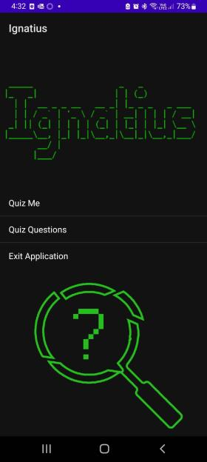

## ImageQuiz ME Activity

This is the activity that is opened when the quiz me option is selected by the user with the purpose of this menu being for user to selected what they want to be quizzed on. This data is pulled from the SQLite using a query like the following “SELECT DISTINCT subject from Questions;”

## Edit Quiz Menu Activity

The Edit quiz menu activity will be what is open the user selects the quiz questions menu all will give users the option to add, delete and show questions that are stored within the quiz bank.

When this activity is opened there will be an alert box message that will inform users on how to use this menu after this the following operations can be performed by the user.  
If the user tries to delete a question that is not stored within the quiz bank they will receive a snack bar message informing them of this, the same thing will also happen if they try to add a duplicate question into the quiz bank.

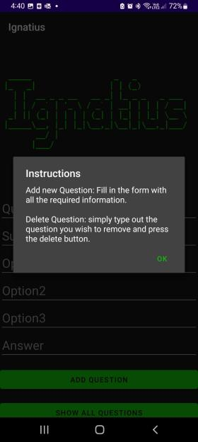 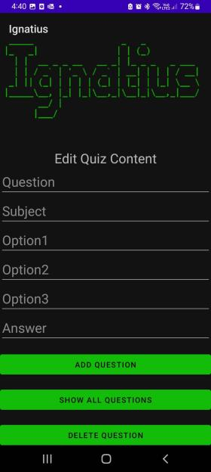

## Question List activity

This activity when the show all questions option is selected by the user use will show all the questions stored within the quiz bank to the user inside of recycler view that will contain the question, the subject, and the correct answer.

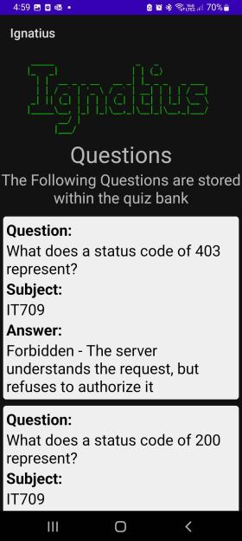

## 5.5 Quiz Activity

The quiz activity will start when the user has chosen what to quizzed on in the previous Menu and will show the user a question followed by three possible answers for the user to select.

Screenshots for what happen happens when right answer is selected, the wrong answer is selected and the screen that will show the user how many questions they got right, and the end of quiz are shown below.

### 5.5.1 Question Display

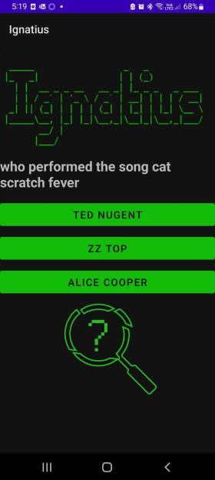

As mentioned earlier this is the main part of the quiz activity in which users will be shown a question and three viable options to choose from with only one of them being the right answer. The response received by user after each question will change depending on whether the correct answer is selected.

### 5.5.2 Incorrect Answer Prompt

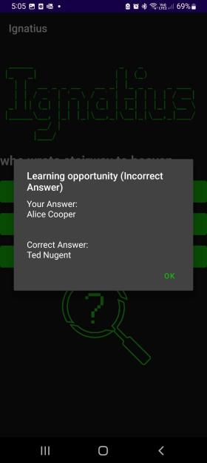When an Incorrect answer is selected by a user is selected by the user an alert box will appear informing them of their selected answer followed by the correct answer.

This is done to provide a learning opportunity for the user rather than just tell them they got the wrong answer.

### 5.5.3 Correct Answer Response

When the correct answer is selected the user will be notified by a snack bar notification on the bottom on of the screen this was originally dine by using a toast message however it was changed to meet the material design requirement of android applications.

### 5.5.4Quiz Result Pop-up

At the end of the quiz an alert box will appear congratulating the user and informing them how many questions they got right. The button on the alert box will send users back the user menu when closed where the user can once again choose whether they want to edit any of the questions within the quiz bank or be quizzed again.

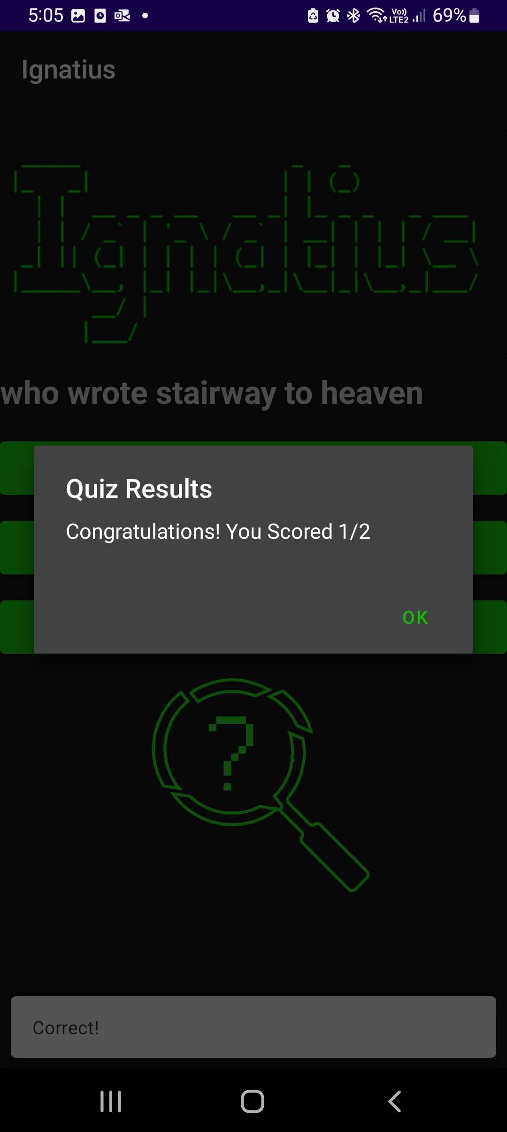

## String Resources

All Text data used for the user Interface has been stored inside of string resources instead of being hardcoded as the user of hardcoded strings is considered bad practice.

By storing strings in resource files rather than hardcoding them it become easier for them to be edited in the future as they only need to be changed in one and they will be changed every that the value is referenced.

Another benefit is that it allows for multi-language support which Ignatius takes advantage by offering both the English and German languages for the user interface components of the application, it is however important to note that user generated content will be limited to the language in which it was created in by the user.

# Testing

As mentioned earlier the application will be tested using my Galaxy A13 as my normal size device and a virtual nexus for the tablet device with screen shots of the following activities and events within the application.

* A Screenshot of the home Screen
* Opening of the edit quiz menu
* A Demonstration of a adding a new question
* A Demonstration of the show all questions menu
* Operation of the quiz functionality including:
  + Screen shot of quiz topic selection menu.
  + What happens when an incorrect answer is selected.
  + What happens when a correct answer is selected.
  + The alert at the end of the quiz showing the users score.
  + The snack bar notifications when questions are added or deleted.

The testing for this will show with both device in both landscape and portrait mode, The A13 Will be in Dark Mode and the Nexus 10 will be in light mode to show the functionality in both color modes.

## 6.1 Samsung Galaxy A13 (Portrait)

### 6.1.1 Quiz Activity (with home screen and Topic Selection)

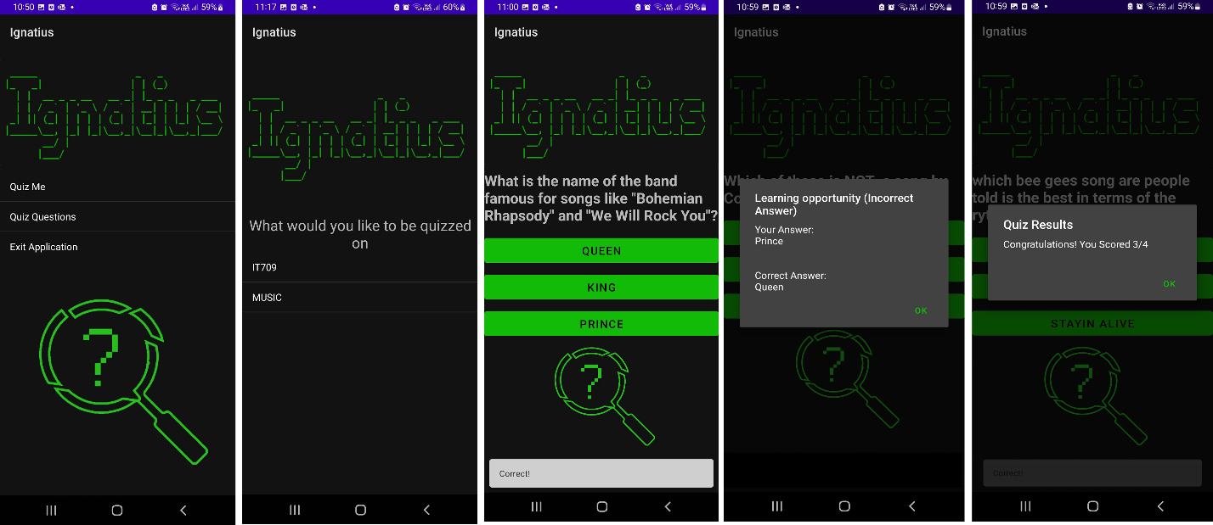

### 6.1.2 Edit Quiz Menu Activity

### 6.1.3 Show all Questions recycler view activity.

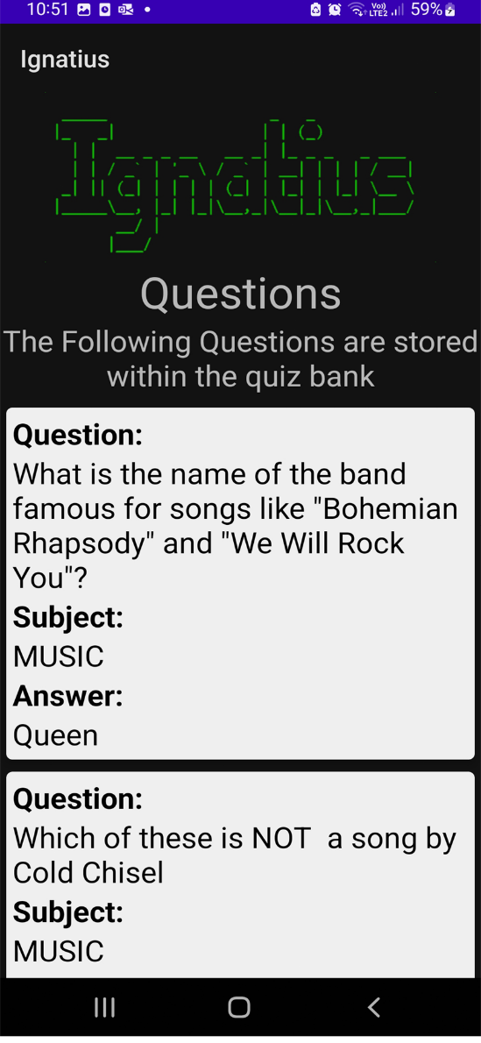

## 6.2 Samsung Galaxy A13 (Landscape)

### 6.2.1Quiz Activity (with home screen and Topic Selection)

### 6.2.2 Edit Quiz Menu activity.

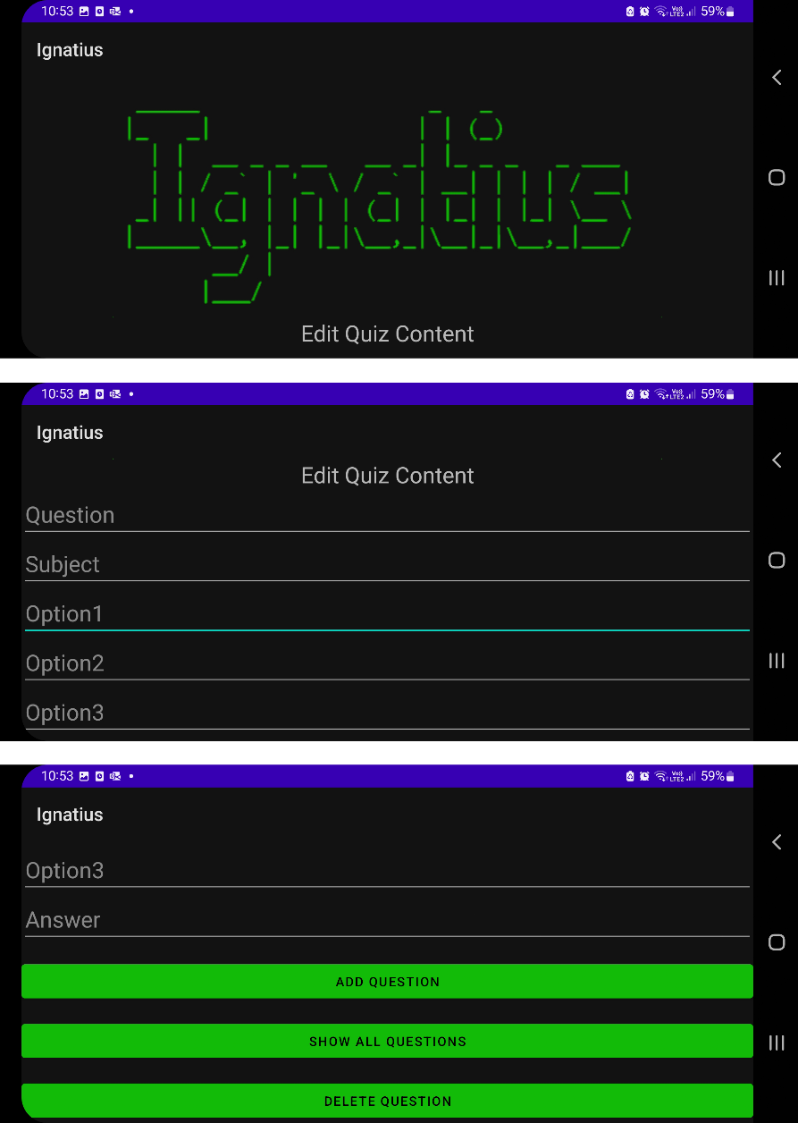

### 6.2.3 Show all Questions recycler view activity

## 6.3 Nexus 10 (Portrait)

### 6.3.1 Home Screen

### 6.3.2 Quiz Activity (With Topic Choice Menu) A screenshot of a quiz Description automatically generated with low confidence A screenshot of a phone Description automatically generated with low confidence A screenshot of a music album Description automatically generated with medium confidenceA screenshot of a video game Description automatically generated with medium confidence

### 6.3.4 Show all Questions recycler view activity.

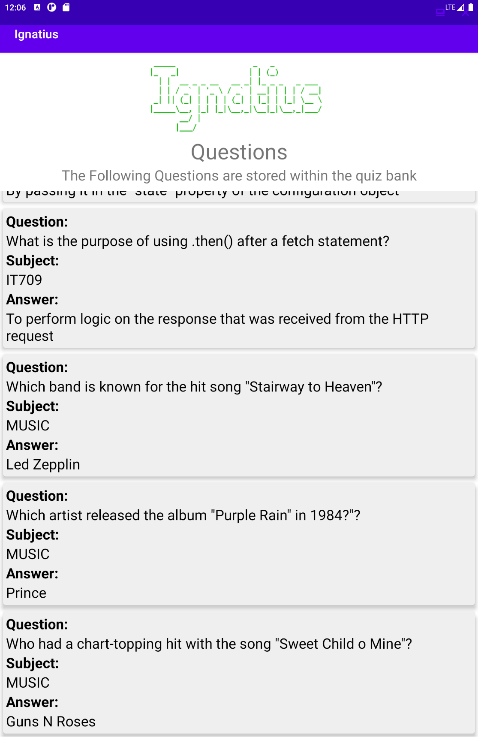

## 6.4 Nexus 10 (Landscape)

### 6.4.1 Home Screen

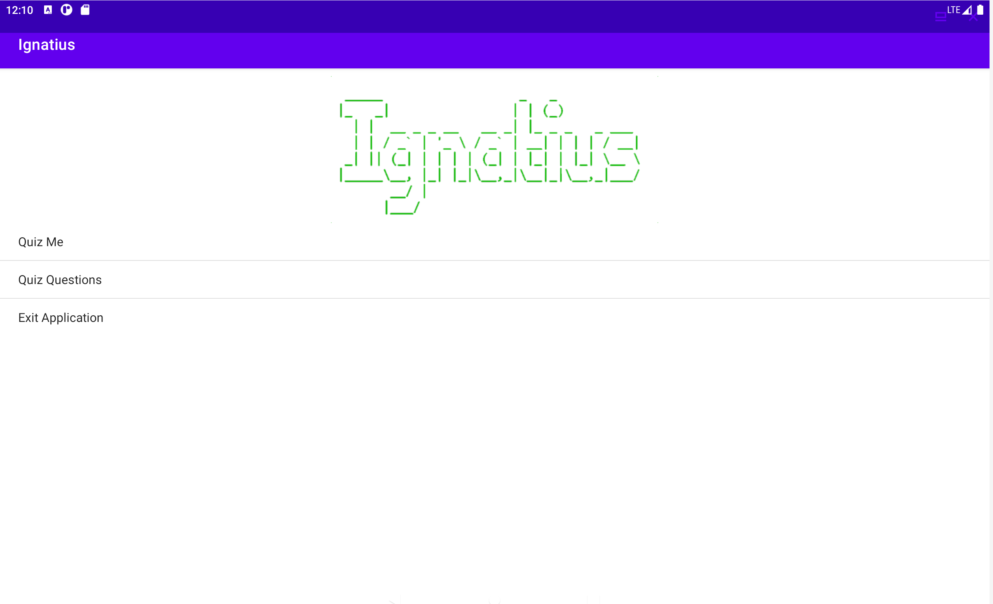

### 6.4.2 Quiz Activity (With Topic Choice Menu)

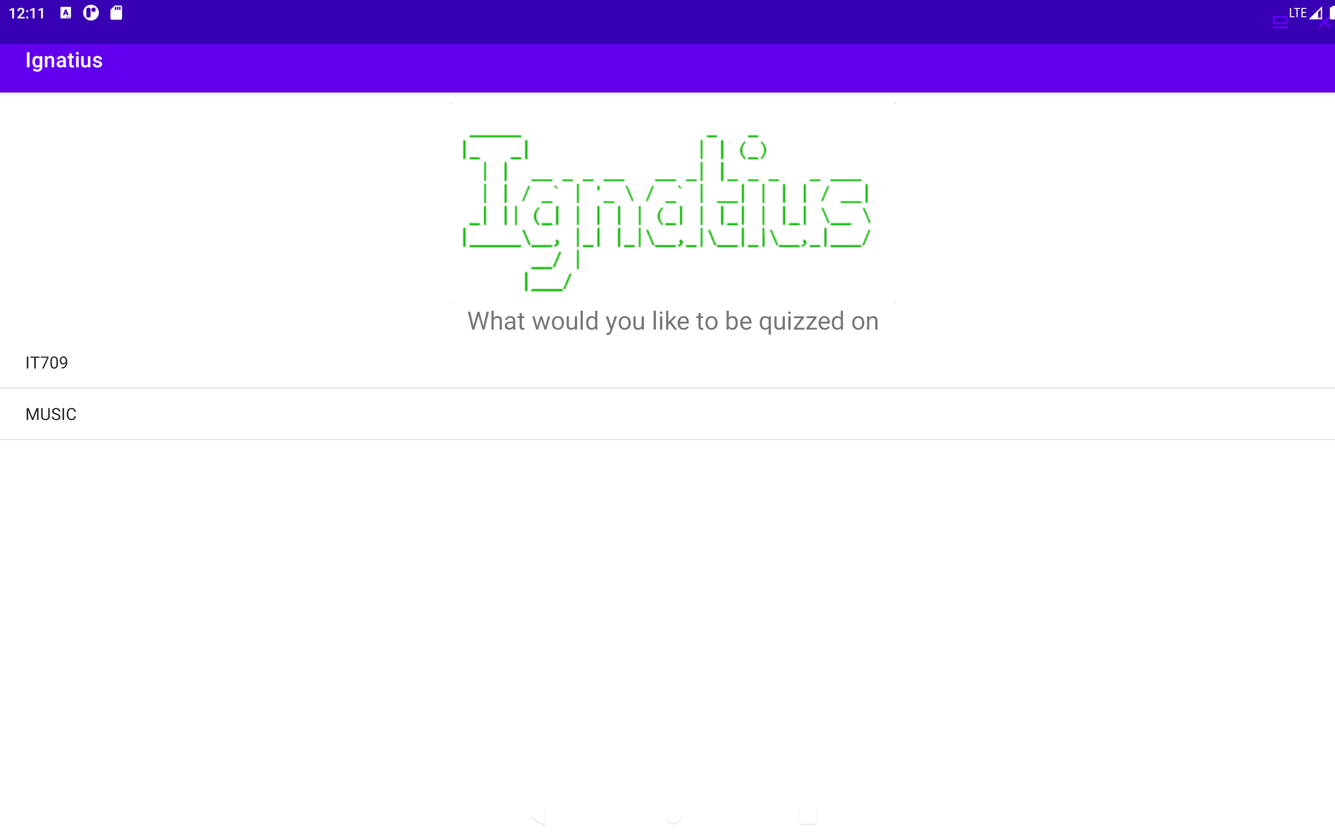 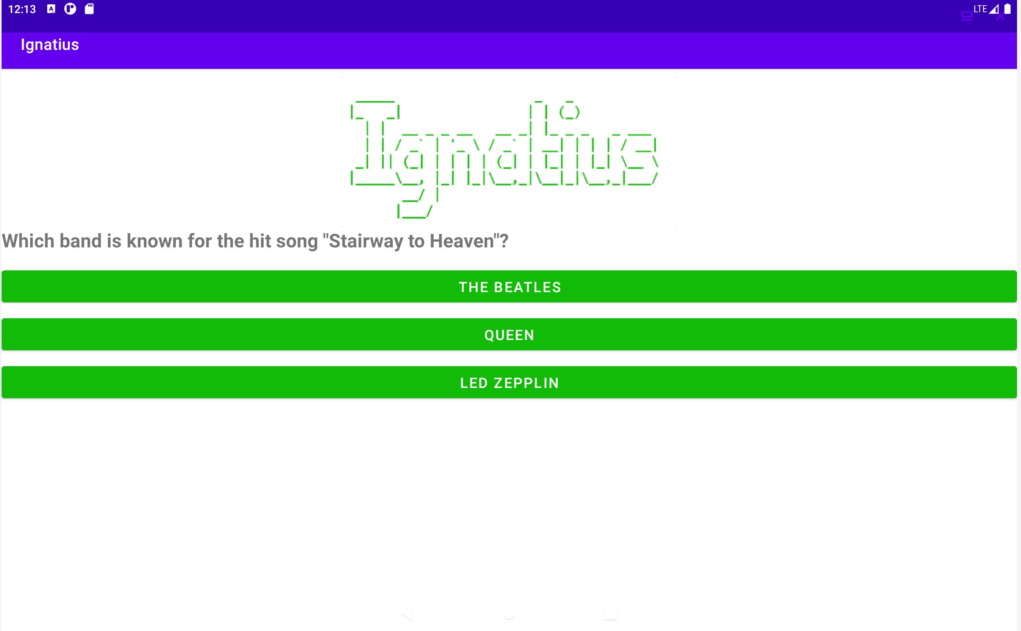

### A screenshot of a computer Description automatically generated A screenshot of a computer Description automatically generated 6.4.3 Edit Quiz Menu Activity

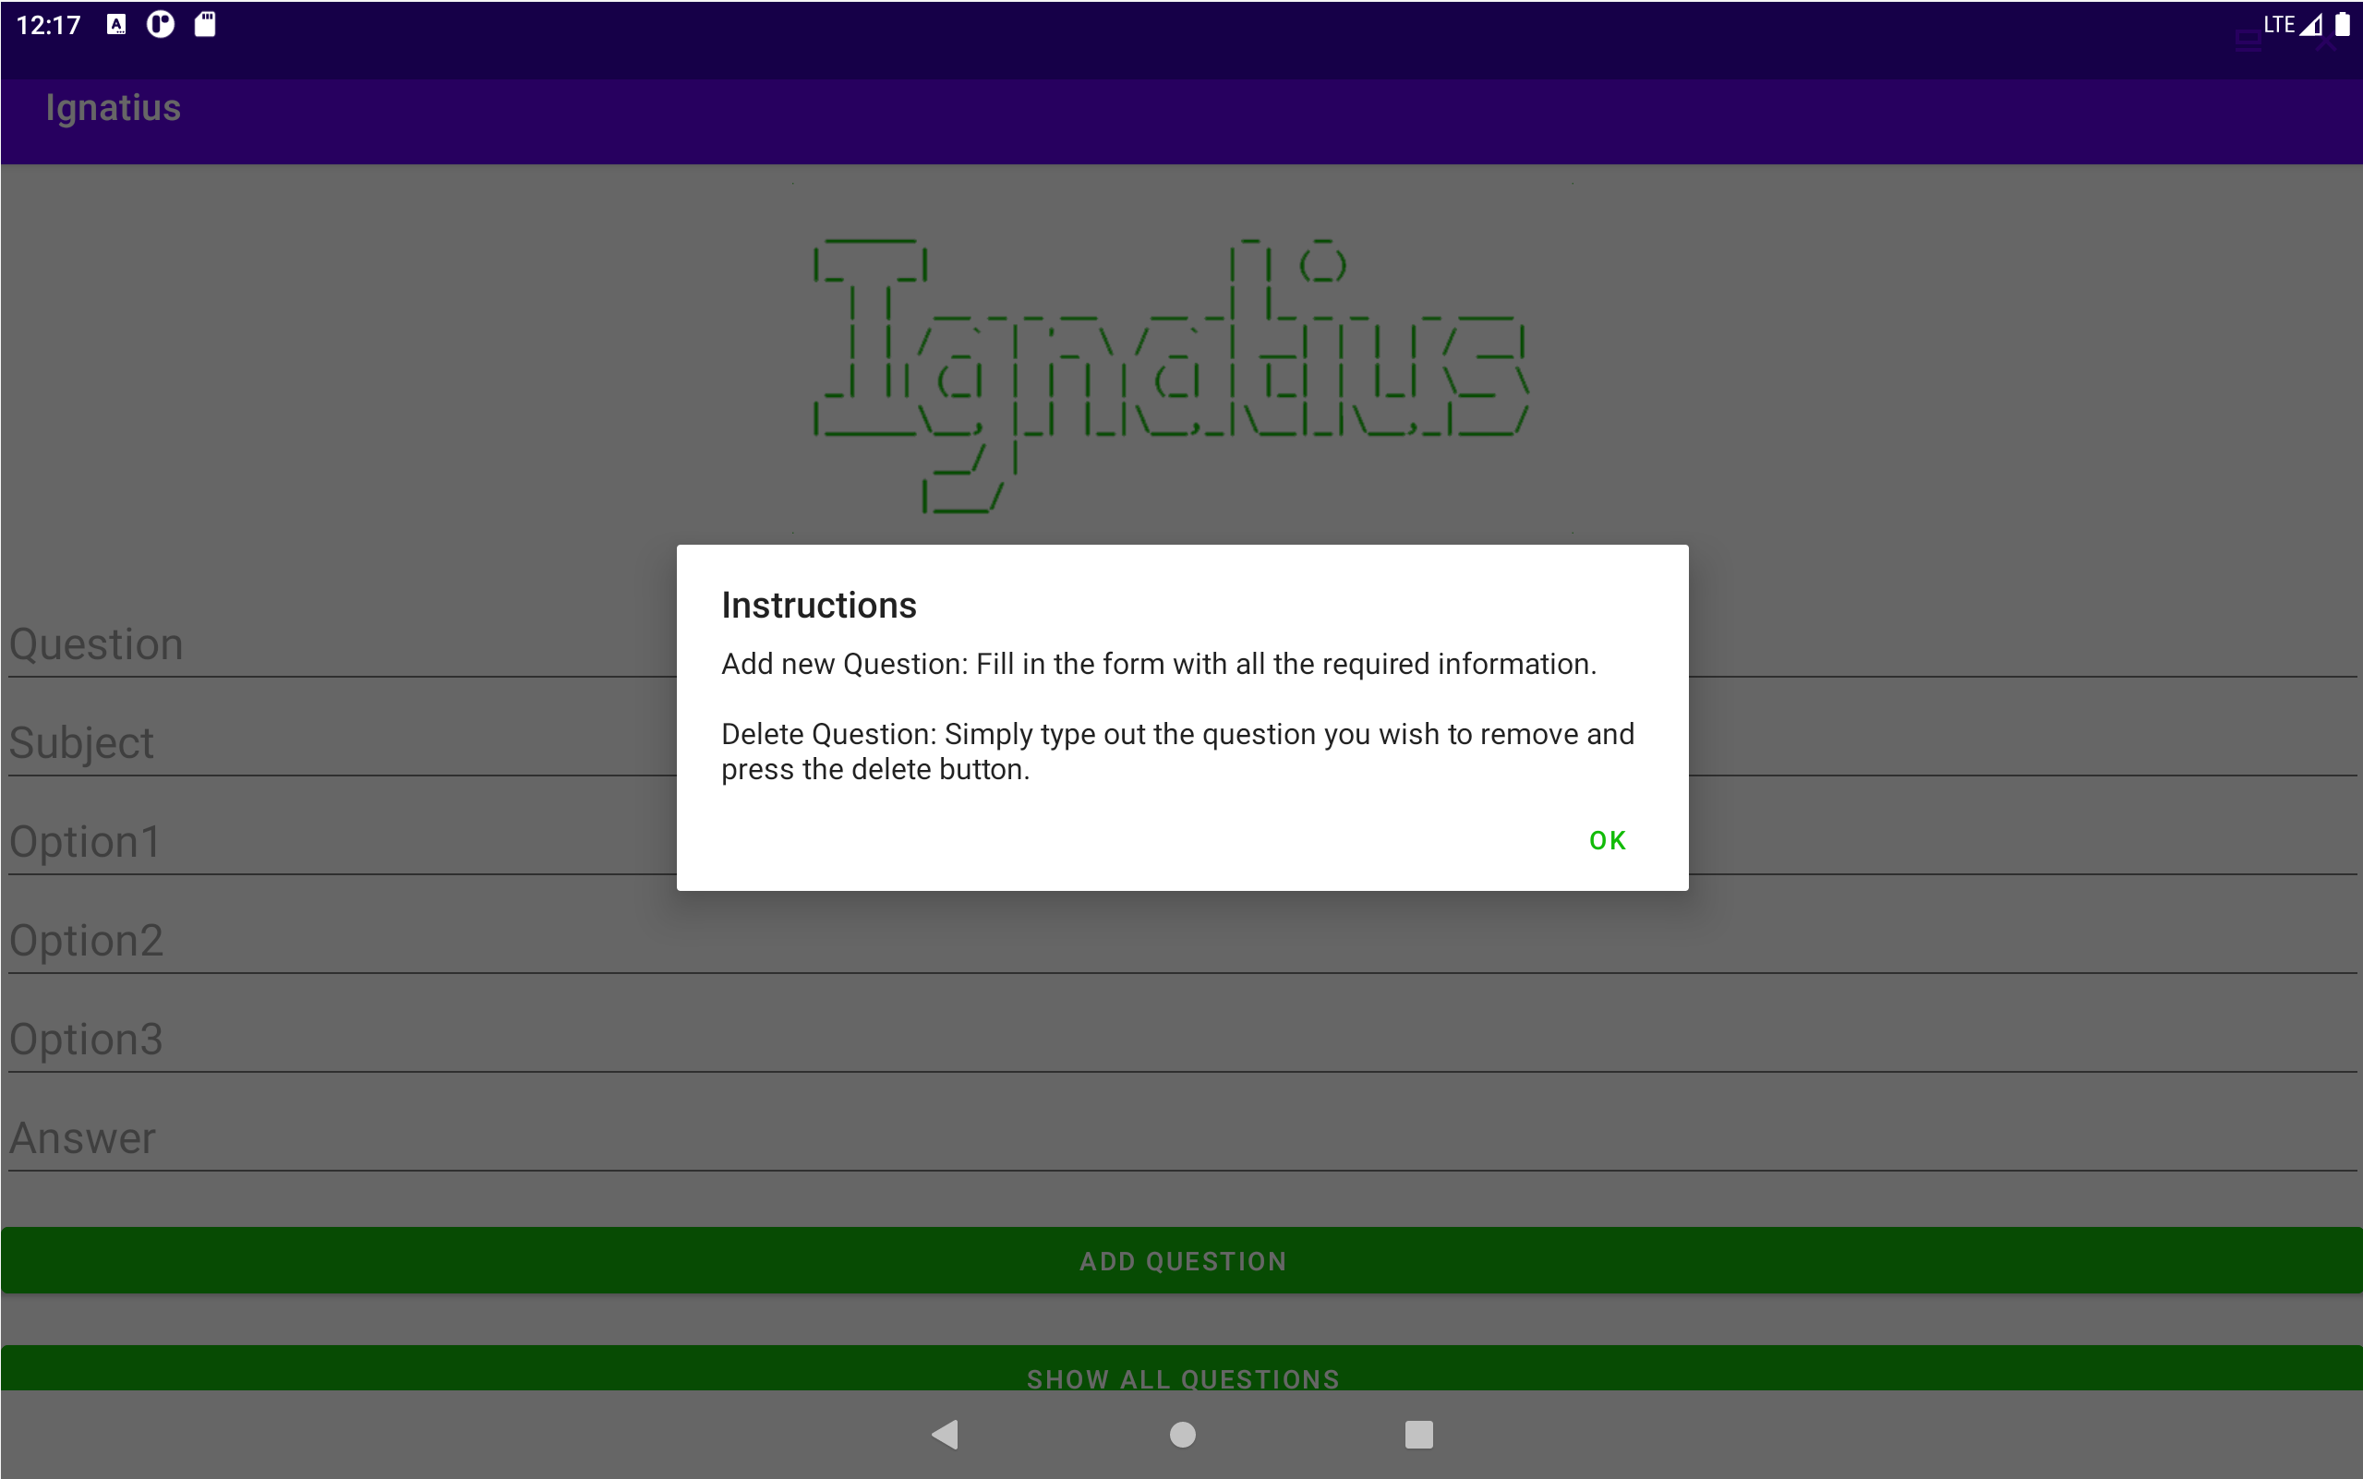 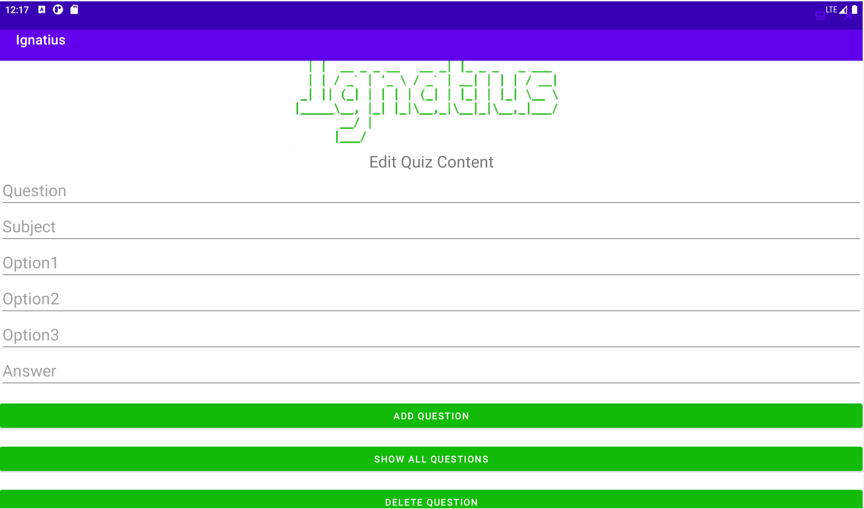

### 6.4.4 Show all Questions recycler view activity.

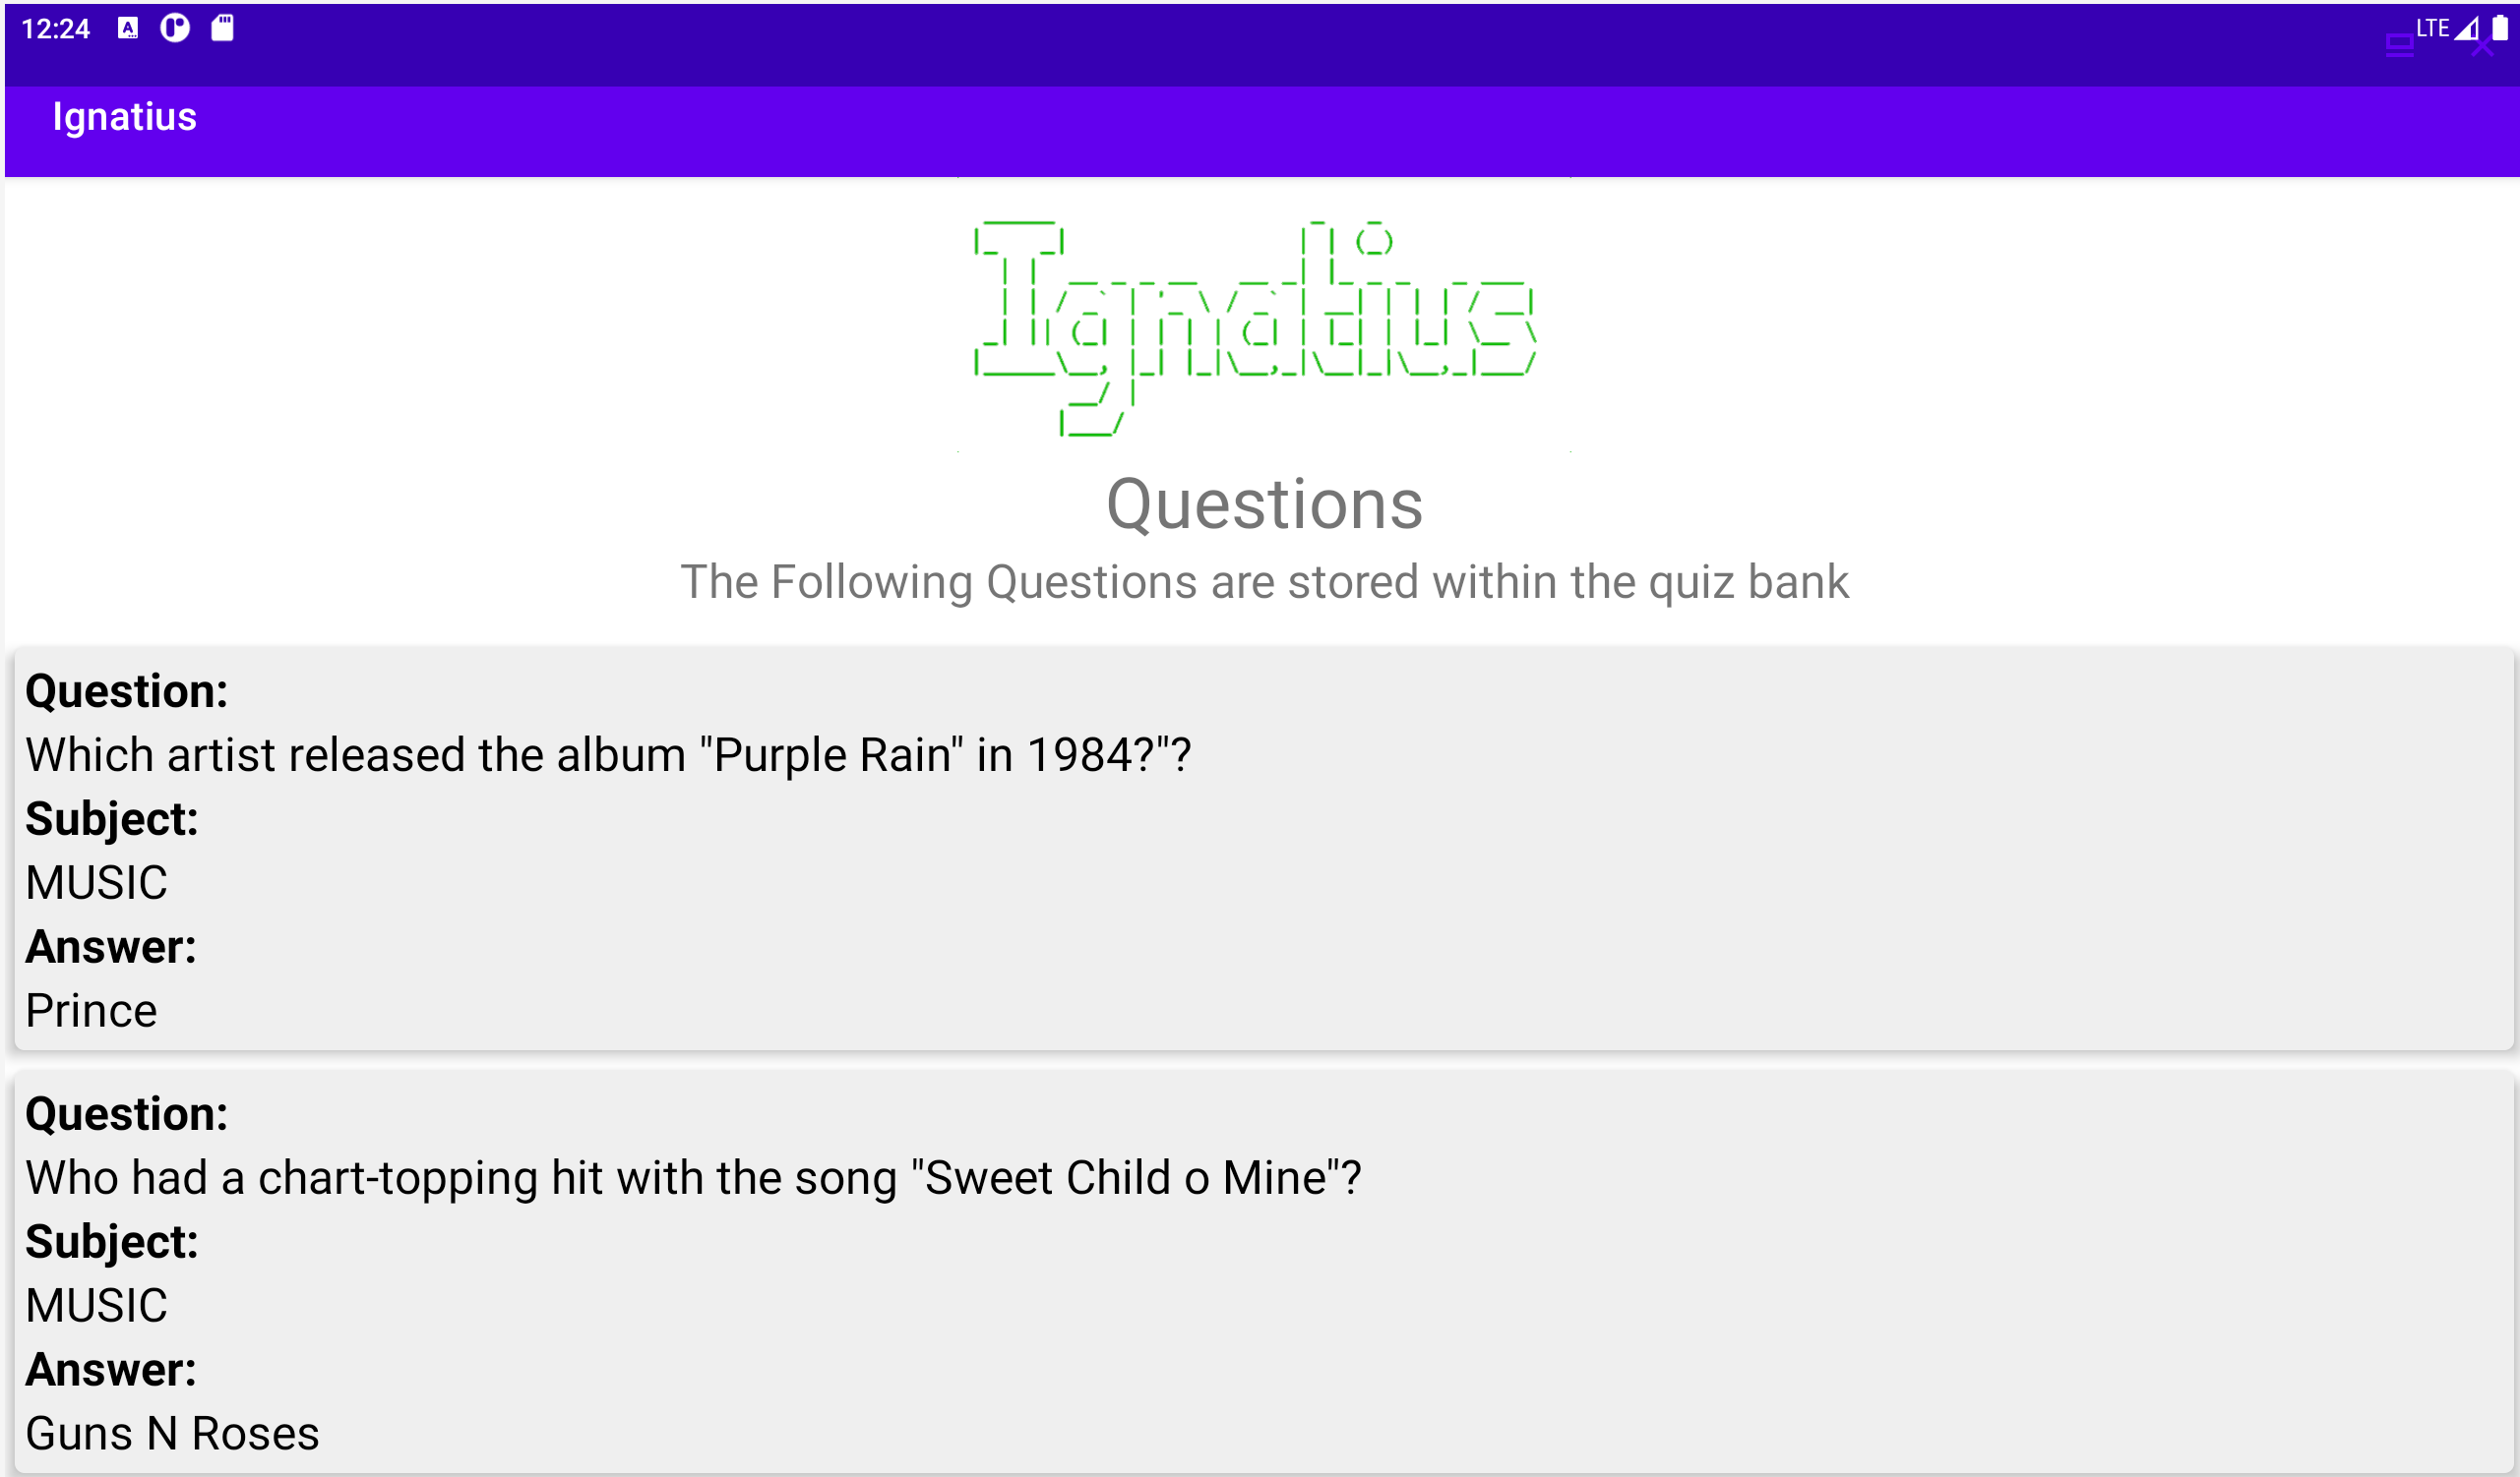

# 6.5 Changes made after initial testing.

Following the initial testing of the application it was then used as a study aid for my end of semester examinations. During this time, it was noted that the following changes to the application.

* Added a counter to the quiz activity so users can see how many questions are in the quiz and what point in the quiz they are at.
* Update the Alert box that comes u when an incorrect answer is selected to display the question, they got wrong, the answer thy selected and the correct answer for this question. Previously this showed only their answer and what the right answer should but after testing I felt this did not provide a valuable learning activity like the title of the alert box suggests.

Evidence of these changes being implemented and tested can be seen below, the testing took place using the Galaxy A13 device Mentioned earlier.   
  
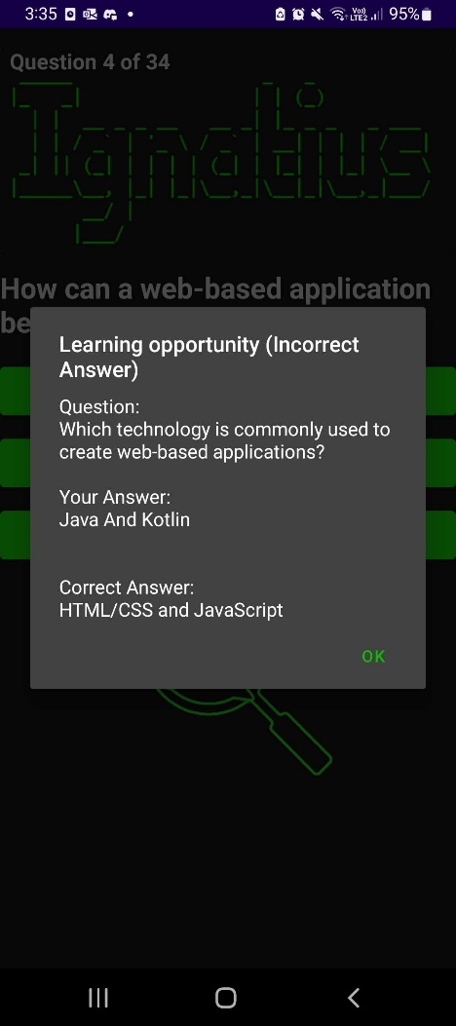 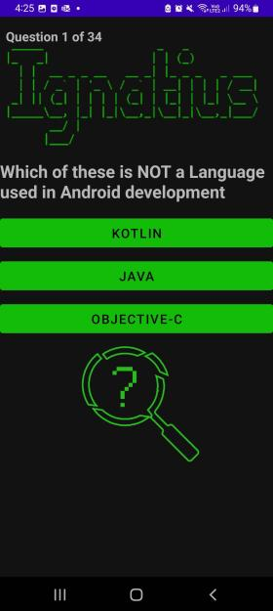

# Conclusion

In conclusion, Ignatius is an adaptation of an existing console application designed to serve as a valuable study aid for end-of-term examinations. The application's functionality allows users to add, remove, and display questions stored in the quiz bank. Additionally, it provides the crucial feature of quizzing users on a topic of their choice with multiple-choice options.

The application supports multiple languages, including English and German. However, user-generated content, such as quiz questions and topics, is limited to the language in which they were added.

To ensure compatibility across various Android devices, including phones and tablets with different screen sizes, Ignatius is targeted for API 26 (Android 8.0 Oreo) and newer, which currently covers over 90 percent of devices running the Android operating system.

To store and display quiz-related data, the application utilizes an SQLite Database with a single table. This table includes fields for questions, subjects, options, and correct answers. The use of the question field as a primary key prevents users from entering duplicate questions into the quiz bank.

The application consists of five main activities: the main activity for choosing between starting the quiz or editing questions in the quiz bank, the edit quiz menu activity for managing quiz content, the theme menu for selecting quiz topics, and the activity where the actual quiz takes place.

String resources are employed to store text data for the application's user interface. This approach ensures easy editing in the future, if necessary, and adheres to the best practice of avoiding hardcoded strings.

During testing, the application was evaluated on two different devices: a Samsung Galaxy A13 and a virtual Nexus 10. The testing covered both portrait and landscape orientations, as well as light and dark modes, to assess functionality across different themes, following Android design principles. Screenshots showcase the functionality of all activities within the app, including the quiz activity, the edit quiz menu, the show questions menu, and the result screen displayed after answering the final question.

After initial additional features were added to the app to provide better learning opportunities when incorrect answers are selected.

Overall, Ignatius has proven to be a valuable study aid for end-of-term examinations. The screenshots captured during testing demonstrate the app's effectiveness in studying for such exams. The fact that the application is now operational on portable devices like smartphones and tablets significantly enhances convenience, as it allows for studying on the go. This is a significant improvement from the original program, which was only accessible on a PC.

# 8. References

AllCodingTutorials. (2020, July 1). *SQLite Database Tutorial Android Studio | Insert, Delete, Update and View Data in SQLite Database*. Retrieved from Youtube: https://www.youtube.com/watch?v=9t8VVWebRFM

AllCodingTutorials. (2022, March 1). *RecyclerView with SQLite Database | Populate RecyclerView with SQLite Database | Source Code*. Retrieved from youtube : https://www.youtube.com/watch?v=6enCz2cY18c

*Develop UI for Android.* (2023). Retrieved from Android Devlopers: https://developer.android.com/develop/ui